NAME: POSSIBLE POINTS: 10

DIRECTIONS:
We are going to step through the entire process from conceptual to a physical prototype for the following resistor circuit.
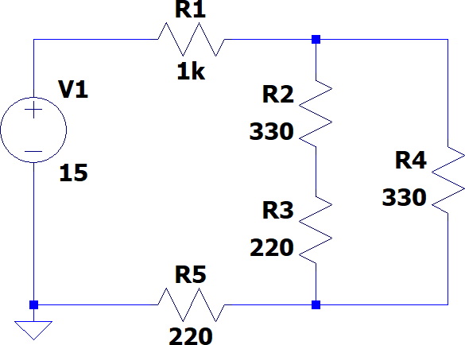

STEP 1 - CALCULATIONS:

Calculate the following for the above circuit and label the current directions with an arrow in the above schematic: I_{R1}, I_{R2}, I_{R3}, I_{R4}, I_{R5}, V_{R1}, V_{R2}, V_{R3}, V_{R4}, V_{R5} . At the end of this lab document this in the provided table to fill in all calculated values. Also include your hand-calculated circuit with this lab write-up.

STEP 2 - MODELING:

Create an LTSpice Model for the above circuit and include a screen capture of the circuit in LTSpice as well as the results from a DC Operating Point analysis. Fill in the table at the end with all LTSpice results for voltages and currents. We refer to this as
verification by modeling the circuit. You’ll find that in practice when designing a product that if the model doesn’t work then there is no chance that the physical implementation will work. The values from this step should match those from Step 1.

STEP 3 - PROTOTYPING:
Create a prototype of the above circuit on your breadboard using your resistor kit and and “hookup” wire to connect the power supply. Also include a picture at the end of the lab write-up showing your finished constructed prototype on the breadboard.

BREADBOARDS:

The best method of experimenting and building simple circuits with leaded components such as resistors is to use a "breadboard" to build circuits. Breadboards, more formally known as solderless modular sockets, get their name from the early days of radio, when it was common to build vacuum tube circuit prototypes on a wooden breadboard.

Today's breadboards are a grid of insulating plastic atop a pattern of conducting metal strips. Here is a top view of a typical breadboard:
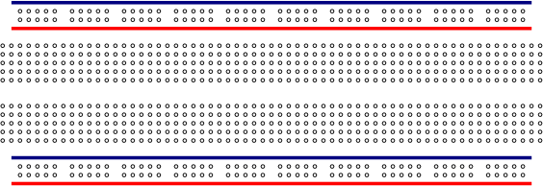

Component leads and wires are inserted into the holes and make contact with the conducting metal strips underneath, thus "connecting" them together.

The pattern of conducting strips underneath the insulating plastic is shown below. Notice there are two horizontal strips along both sides of the breadboard and a series of shorter vertical strips. The two horizontal strips are normally used for power supply connections, with one strip being the supply voltage and the other being the ground connection. The horizontal strips are often known as rails.

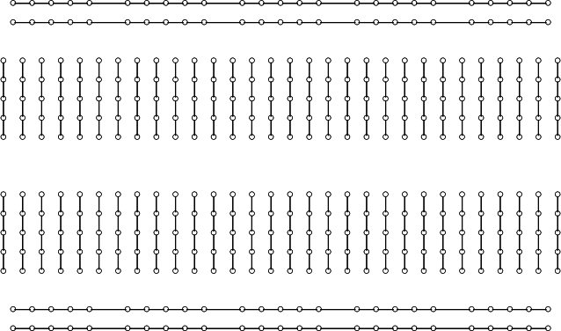

Note the gap separating the vertical strips. The dual in-line package (DIP) IC is normally placed across this gap. One row of pins is one side of the gap, and the other row of pins is on the opposite side.

Leaded components such as resistors, capacitors and transistors are connected between vertical strips or between a strip and the power or ground rail. Wires can also be used as jumpers to interconnect vertical strips.

Breadboards come in a variety of sizes, and are usually measured in terms of the number of connection or "tie points" provided. Some breadboards come with binding posts for connecting a power supply; deluxe models have power supplies built in and with additional supports for potentiometers, LEDs, and meters.

Example of Neat Layout and Construction
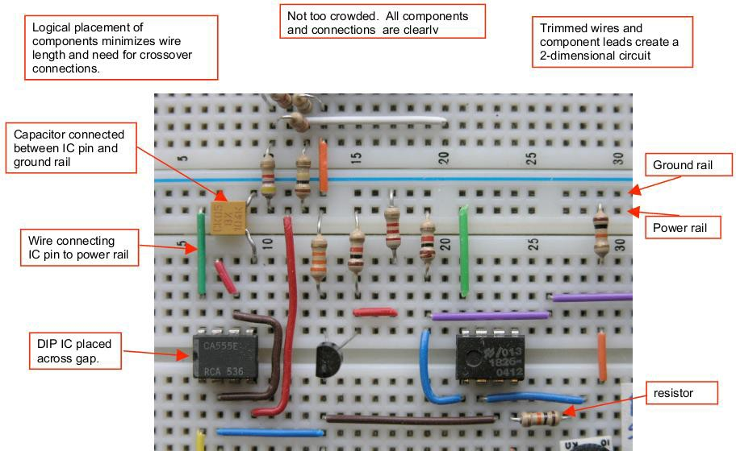

RESISTORS:
Resistors are commonly used in electronic circuits, along with other components such as capacitors, inductors, and active devices such as transistors and integrated circuits (commonly called ICs). Resistors may be connected in series and/or parallel for many reasons, such as to reduce a voltage to a convenient value (as in a voltage divider) or to provide a value different from one that is commercially available. You therefore need to be able to find the equivalent resistance of various combinations of individual elements.

Resistors have a nominal value indicated by colored bands or other labeling. Refer to a color-code chart to interpret the nominal value indicated by the colored bands. The actual (measured) resistance will vary from the nominal value due to subtle mechanical and chemical differences that occur during manufacturing. The manufacturer specifies the maximum deviation from the nominal value as a ±percentage. This range of deviation is called the tolerance of the resistor family. Typical tolerance values are ±1%, ±5%, or ±10%. Some resistors in your lab kit are 5%, which is indicated by a fourth band that is gold in color.
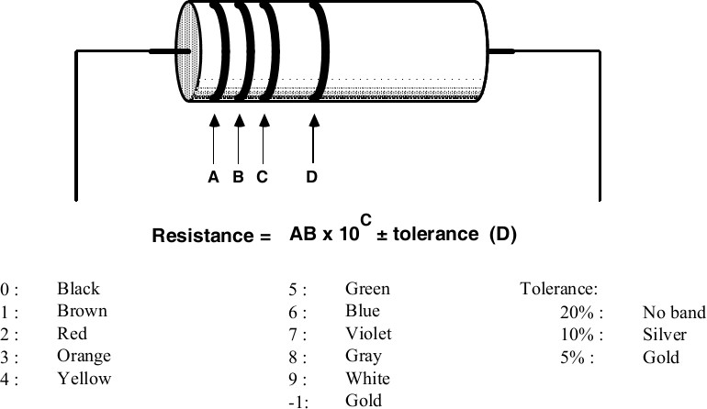

For example:
- a 1 kΩ± 5% resistor [10 ×10² ] is labeled BROWN:BLACK:RED:GOLD
- a 220Ω± 10 % resistor is labeled RED:RED:BROWN:SILVER, and
- a 1Ω± 5% resistor must be represented as [10 ×10⁻¹ ], or BROWN:BLACK:GOLD:GOLD.
Note that some resistors have a 1% tolerance rating, and this requires an extra digit of precision. One percent tolerance resistors usually have a light blue colored body, and five stripes (ABCDE) interpreted as ABC ×10 D ±tolerance (E), where the E band is brown in color for a 1% resistor.

RESULTS VERIFICATION:

Use your physical Digital Multimeter (DMM) to find the value of the following: (We will discuss how to properly use a DMM in lab.

 | Step 1 - Calculate | Step 2 - Simulate | Step 3 – Using DMM | Error - Difference of Step  1 & 3 (Step 1 – Step 3)
R₁ | 1K | 1K
R₂ | 330 | 330
R₃ | 220 | 220
R₄ | 330 | 330
R₅ | 220 | 220
Rt |  | ----------------------
IR1
IR2
IR3
IR4
IR5
VR1
VR2
VR3
VR4
VR5

- Include Hand Calculated Circuit -

- Include Picture of Finished Prototype Here -

